Uniform Mitigation Verification Inspection Form
06/07/2018
Owner Information
Opal at Sapphire Lakes Condo Association |  | Bob Barker
409 Gabriel Circle
Naples | 34104
COLLIER |  | 508-655-4095
1992

NOTE: Any documentation used in validating the compliance or existence of each construction or mitigation attribute must accompany this form. At least one photograph must accompany this form to validate each attribute marked in questions 3 though 7. The insurer may ask additional questions regarding the mitigated feature(s) verified on this form.
Building Code

Roof Covering:

2.1 Roof Covering Type:

Permit Application Date

FBC or MDC
Product Approval #

PRBD2018-0210424
2/15/2018

Year of Original Installation or Replacement
No Information Provided for
Compliance

Inspectors Initials KPN
Property Address 409 Gabriel Circle
Naples

Roof Deck Attachment
weakes

*This verification form is valid for up to five (5) years provided no material changes have been made to the structure or inaccuracies found on the form.
OIR-B1-1802 (Rev. 01/12) Adopted by Rule 69O-170.0155 Page 1 of 4

Any system of screws, nails, adhesives, other deck fastening system or truss/rafter spacing that is shown to have an equivalent or greater resistance than 8d common nails spaced a maximum of 6 inches in the field or has a mean uplift resistance of at least 182 psf.
D D. Reinforced Concrete Roof Deck.
D E. Other:
---------------------
D
F. Unknown or unidentified.
D G. No attic access.
- Roof to Wall Attachment: What is theWEAKEST roof to wall connection ? (Do not include attachment of hip/valley jacks within 5 feet of the inside or outside comer of the roof in determination of WEAKEST type)
D A. Toe Nails
D Truss/rafter anchored to top plate of wall using nails driven at an angle through the truss/rafter and attached to the top plate of the wall, or
D Metal connectors that do not meet the minimal conditions or requirements ofB, C, or D

Minimal conditions to qualify for categories B, C, or D. All visible metal connectors are:
Secured to truss/rafter with a minimum of three (3) nails,and
Attached to the wall top plate of the wall framing, or embedded in the bond beam, with less than a½" gap from the blocking or truss/rafterand blocked no more than 1.5" of the truss/rafter,and free of visible severe corrosion.

- Clips

Metal connectors that do not wrap over the top of the truss/rafter,or
D Metal connectors with a minimum of 1 strap that wraps over the top of the truss/rafter and does not meet the nail position requirements of C or D, but is secured with a minimum of 3 nails.

D C. Single Wraps
Metal connectors consisting of a single strap that wraps over the top of the truss /rafter and is secured with a minimum of2 nails on the front side and a minimum of 1 nail on the opposing side.
D D. Double Wraps
D Metal Connectors consisting of2 separate straps that are attached to the wall frame, or embedded in the bond beam, on either side of the truss/rafter where each strap wraps over the top of the truss/rafter and is secured with a minimum of 2 nails on the front side, and a minimum of 1 nail on the opposing side,or
D Metal connectors consisting of a single strap that wraps over the top of the truss/rafter, is secured to the wall on both sides, and is secured to the top plate with a minimum of three nails on each side.
D E. Structural Anchor bolts structurally connected or reinforced concrete roof.
D F. Other:
D G. Unknown or unidentified
D H. No attic access
- Roof Geometry: What is the roof shape? (Do not consider roofs of porches or carports that are attached only to the fascia or wall of the host structure over unenclosed space in the determination of roof perimeter or roof area for roof geometry classification).
D A. Hip Roof Hip roof with no other roof shapes ater than 10% of the total roof system perimeter.
Total length of non-hip features:96 feet; Total roof system perimeter:516 feet
D B. Flat Roof Roof on a building with 5 or more units where at least 90% of the main roof area has a roof slope of less than 2:12. Roof area with slope less than 2:12 sq ft; Total roof area sq ft
- Other Roof Any roof that does not qualify as either (A) or (B) above.

- Secondary Water Resistance (SWR): (standard underlayments or hot-mopped felts do not qualify as an SWR)
  - SWR (also called Sealed Roof Deck) Self-adhering polymer modified-bitumen roofing underlayment applied directly to the sheathing or foam adhesive SWR barrier (not foamed-on insulation) applied as a supplemental means to protect the
dwelling from water intrusion in the event of roof covering loss.
D B. No SWR.
D C. Unknown or undetermined.

Opening Protection:
weakest
First
Second
and

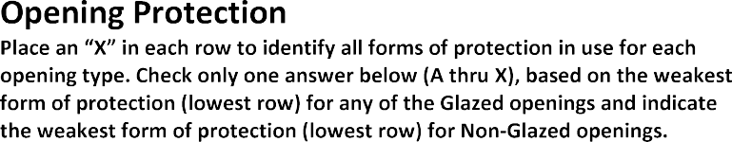 |  |  |  |  |  | 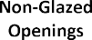
 |  | 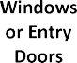 | 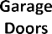 |  |  |  | 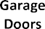

A. Exterior Openings Cyclic Pressure and 9-lb Large Missile (4.5 lb for skylights only)

and

and

and

and

B. Exterior Opening Protection- Cyclic Pressure and 4 to 8-lb Large Missile (2-4.5 lb for skylights only)
and
and

C. Exterior Opening Protection- Wood Structural Panels meeting FBC 2007

________________________

N. Exterior Opening Protection (unverified shutter systems with no documentation)

X. None or Some Glazed Openings

MITIGATION INSPECTIONS MUST BE CERTIFIED BY A QUALIFIED INSPECTOR.
Section 627.711(2), Florida Statutes, provides a listing of individuals who may sign this form.
Kevin P. Noack | Home Inspector |  | HI 9868
Florida Property Inspectors, Inc |  | 239-209-2366
Qualified Inspector – I hold an active license as a: (check one)

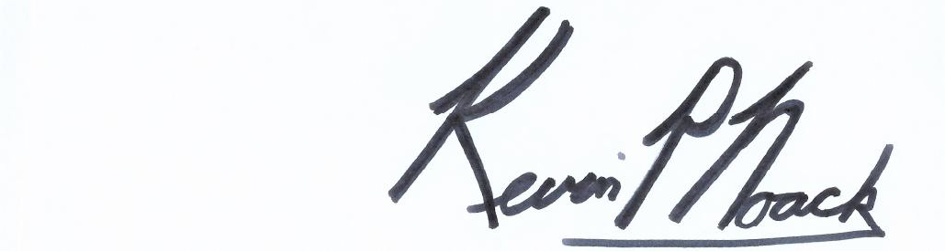
An individual or entity who knowingly or through gross negligence provides a false or fraudulent mitigation verification form is subject to investigation by the Florida Division of Insurance Fraud and may be subject to administrative action by the appropriate licensing agency or to criminal prosecution. (Section 627.711(4)-(7), Florida Statutes) The Qualified Inspector who certifies this form shall be directly liable for the misconduct of employees as if the authorized mitigation inspector personally performed the inspection.
Date: 06/07/2018
Qualified Inspector Signature:
(print name)
contractors and professional engineers only) I had my employee ( ) perform the inspection
(print name of inspector)
and I agree to be responsible for his/her work.
am a qualified inspector and I personally performed the inspection or (licensed
I, Kevin P. Noack
Individuals other than licensed contractors licensed under Section 489.111, Florida Statutes, or professional engineer licensed under Section 471.015, Florida Statues, must inspect the structures personally and not through employees or other persons. Licensees under s.471.015 or s.489.111 may authorize a direct employee who possesses the requisite skill, knowledge, and experience to conduct a mitigation verification inspection.

An individual or entity who knowingly provides or utters a false or fraudulent mitigation verification form with the intent to obtain or receive a discount on an insurance premium to which the individual or entity is not entitled commits a misdemeanor of the first degree. (Section 627.711(7), Florida Statutes)

The definitions on this form are for inspection purposes only and cannot be used to certify any product or construction feature as offering protection from hurricanes.
Homeowner to complete:

Signature: Date: 06/07/2018
_

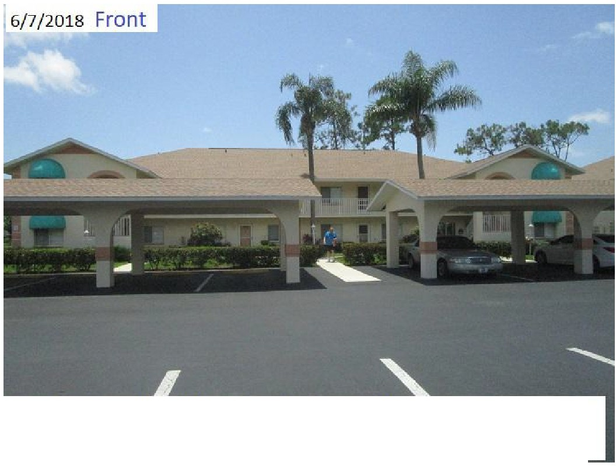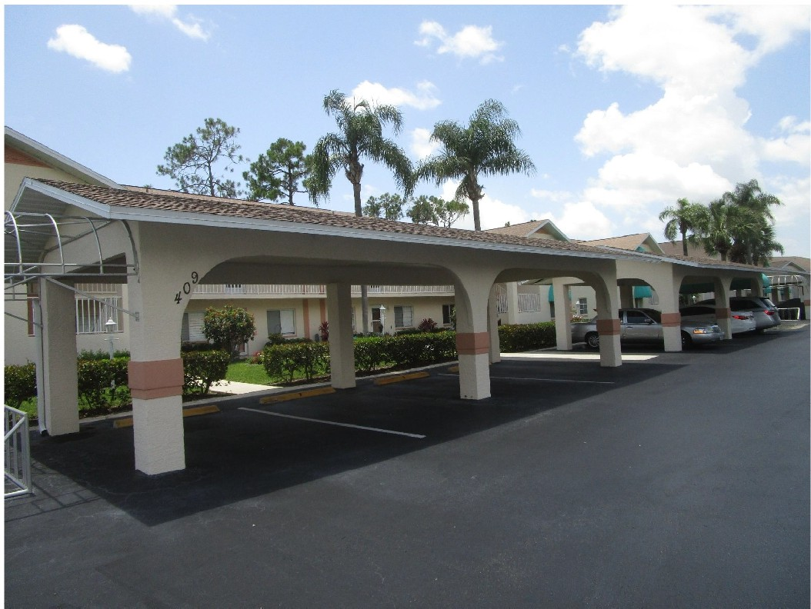

Opal at Sapp hire Lakes Condo Asso ciat ion: 409 Gabr iel Circle Naples bu il t 1992

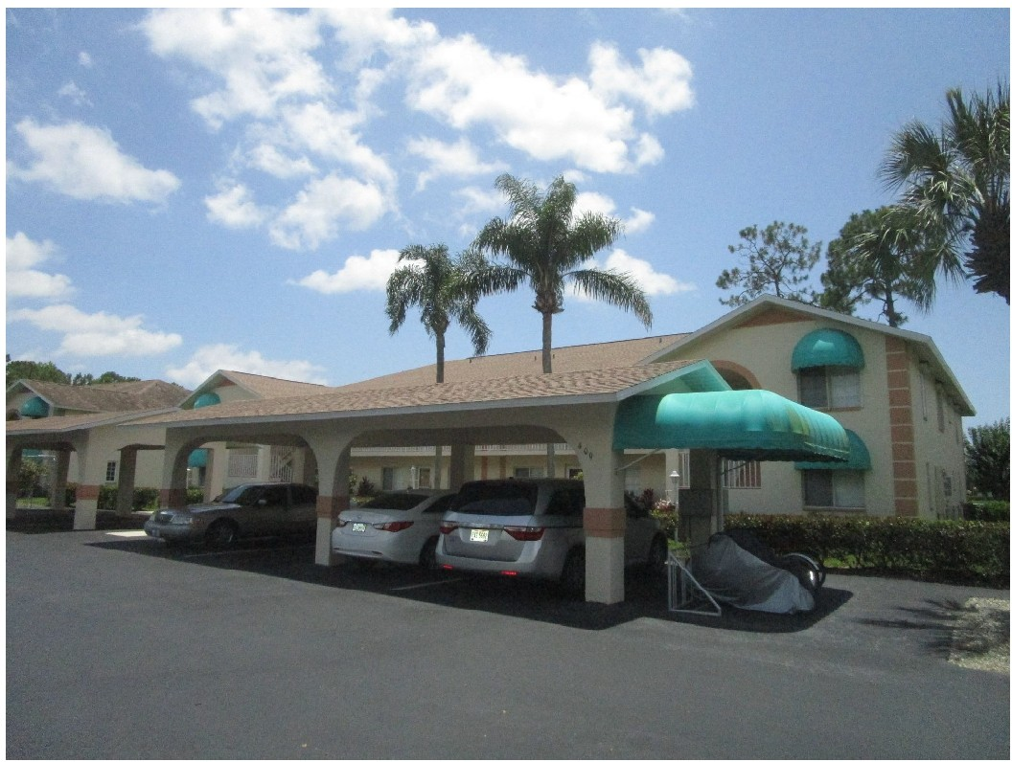
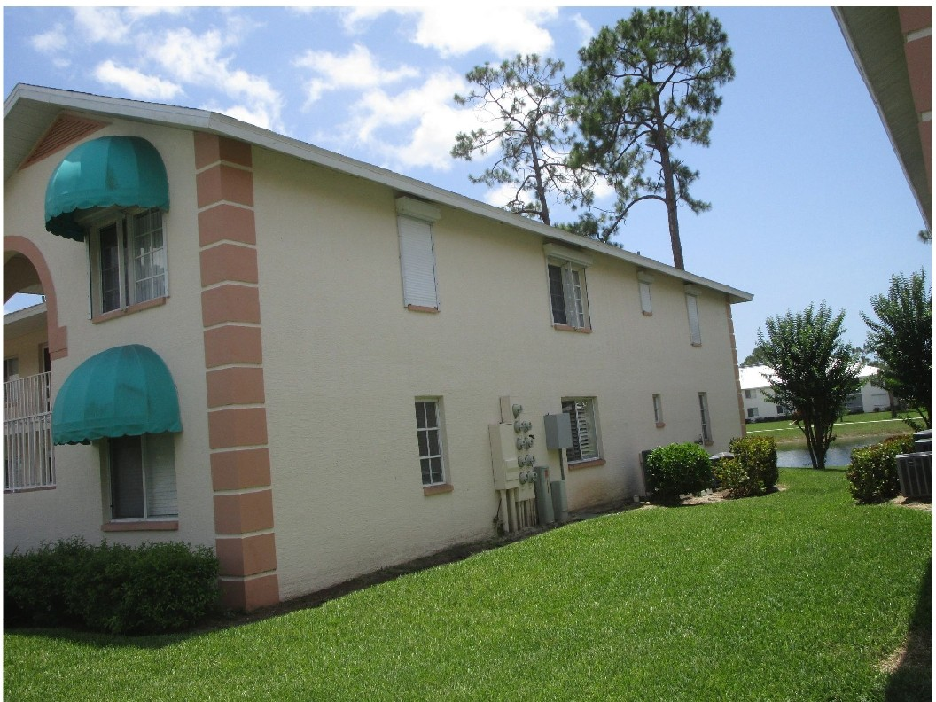

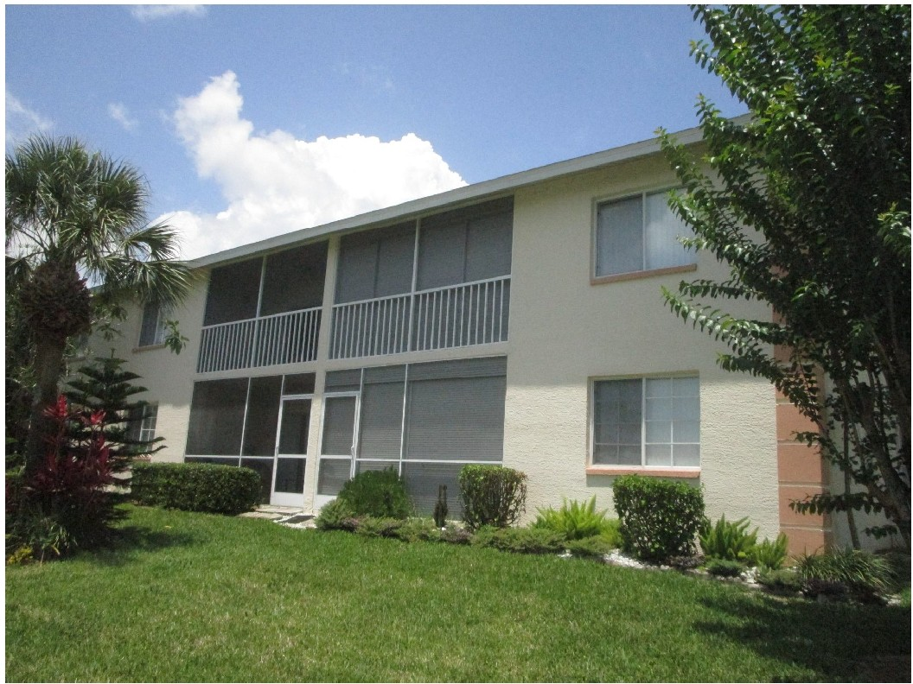
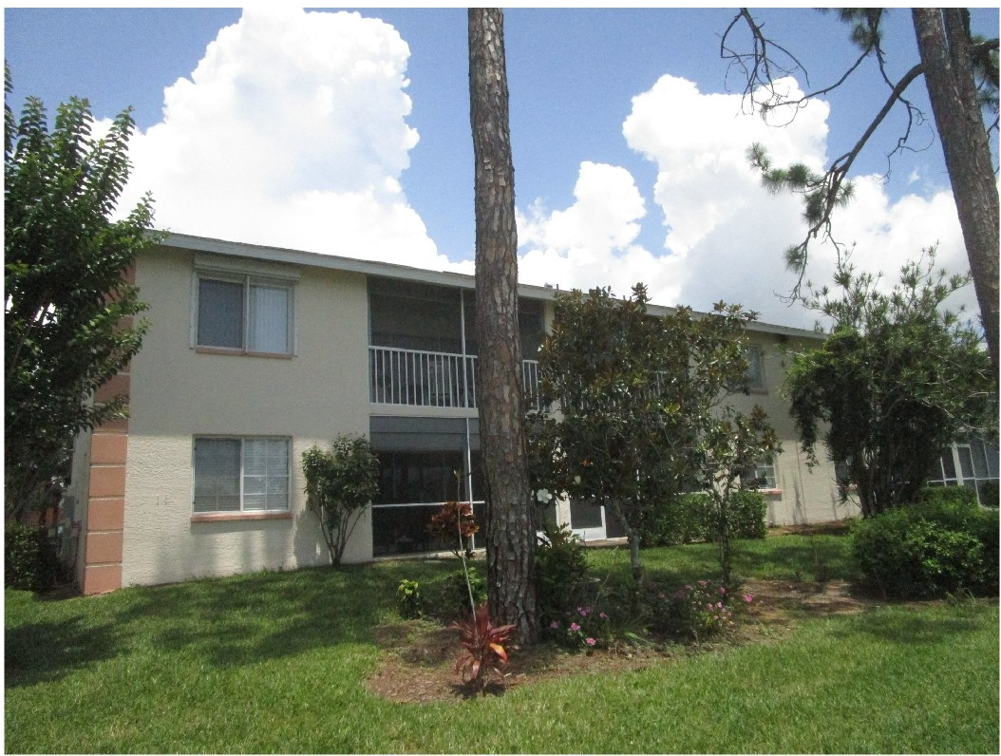

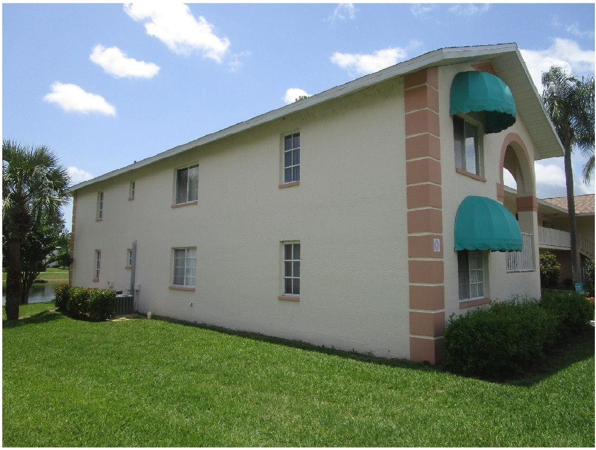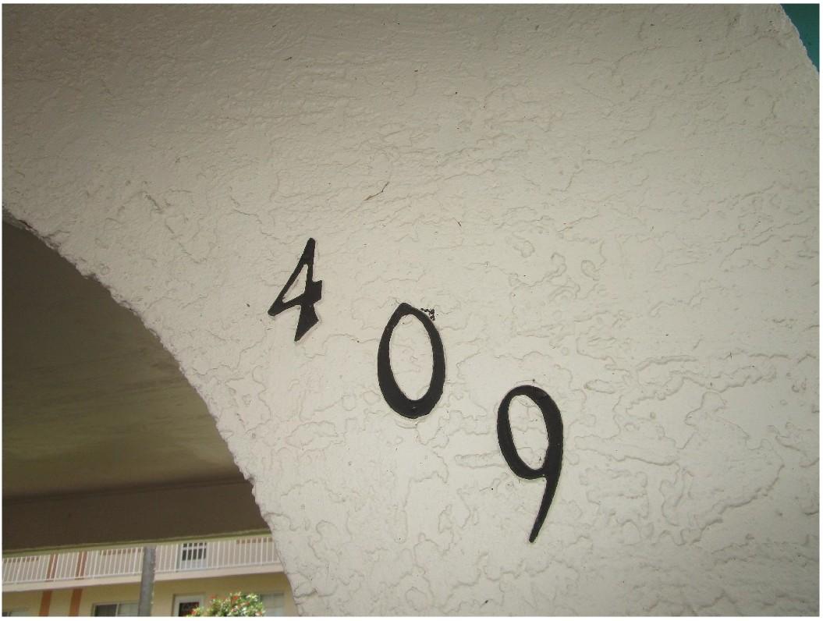

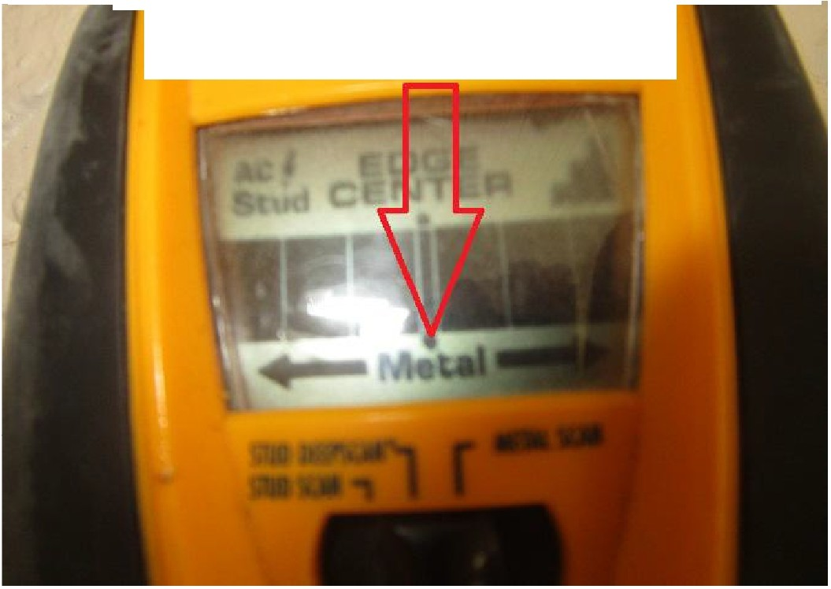
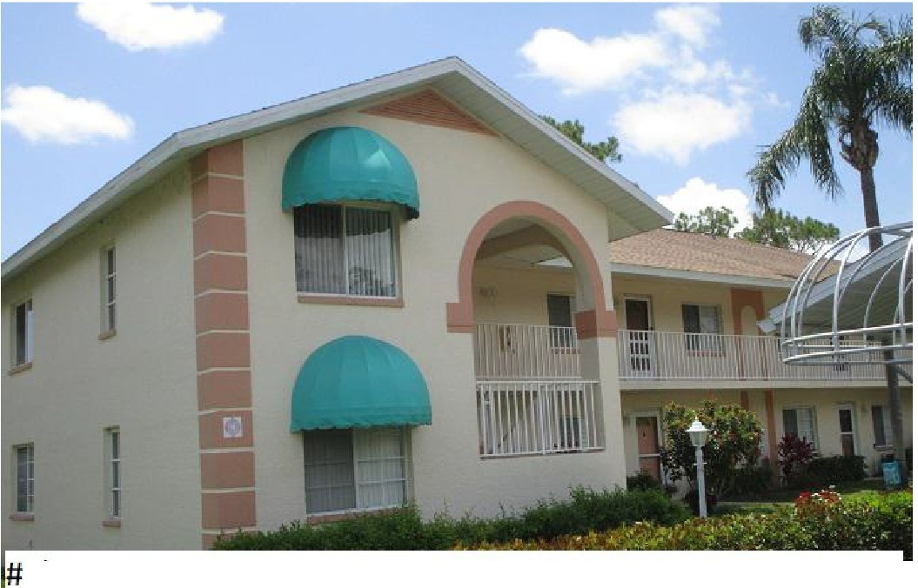* *wall type construction: 85% reinforced masonry

5) roof geometry: "other " style roof
*96' gables vs 516' total roof perimeter or +10%
* *wall t e construction: 85% reinforced masonry

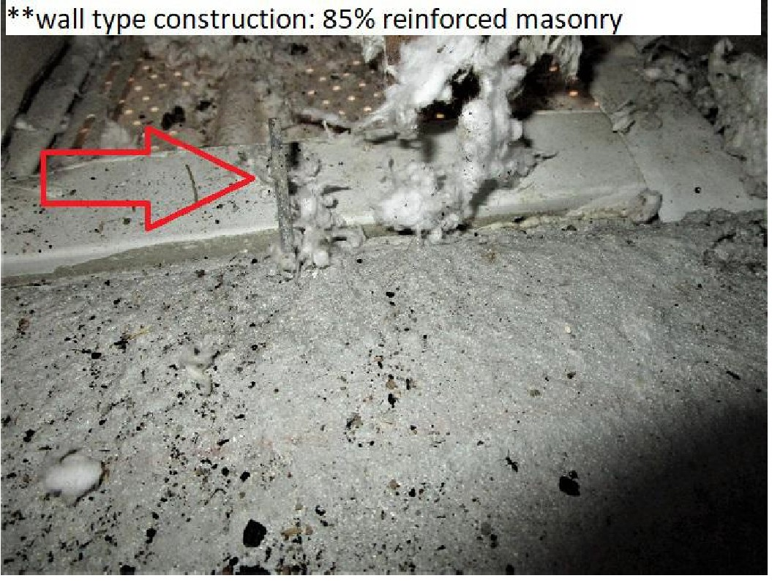
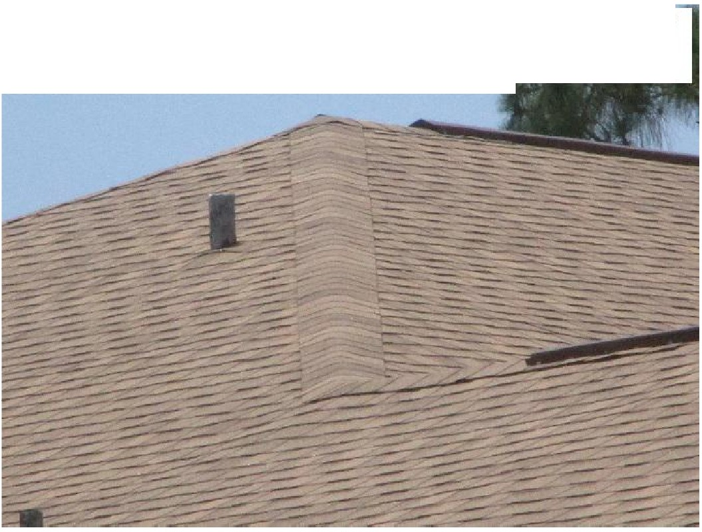
#2) roof covering: 2018 dimensional asphalt shingle "other" style roof PRBD2018-0210424 issued 2/15/2018

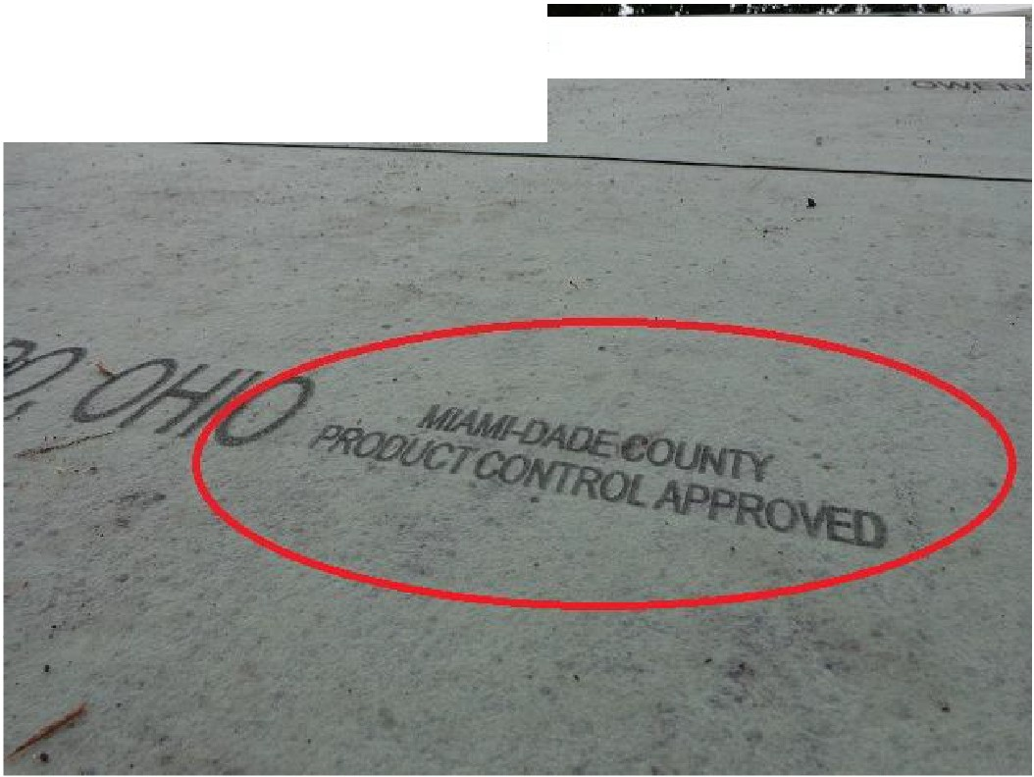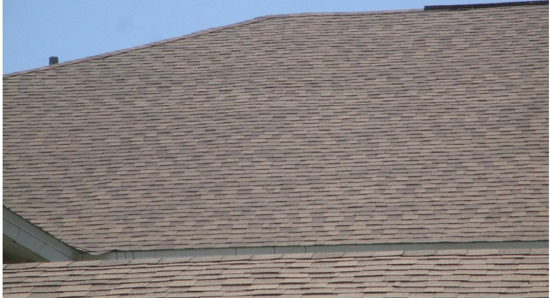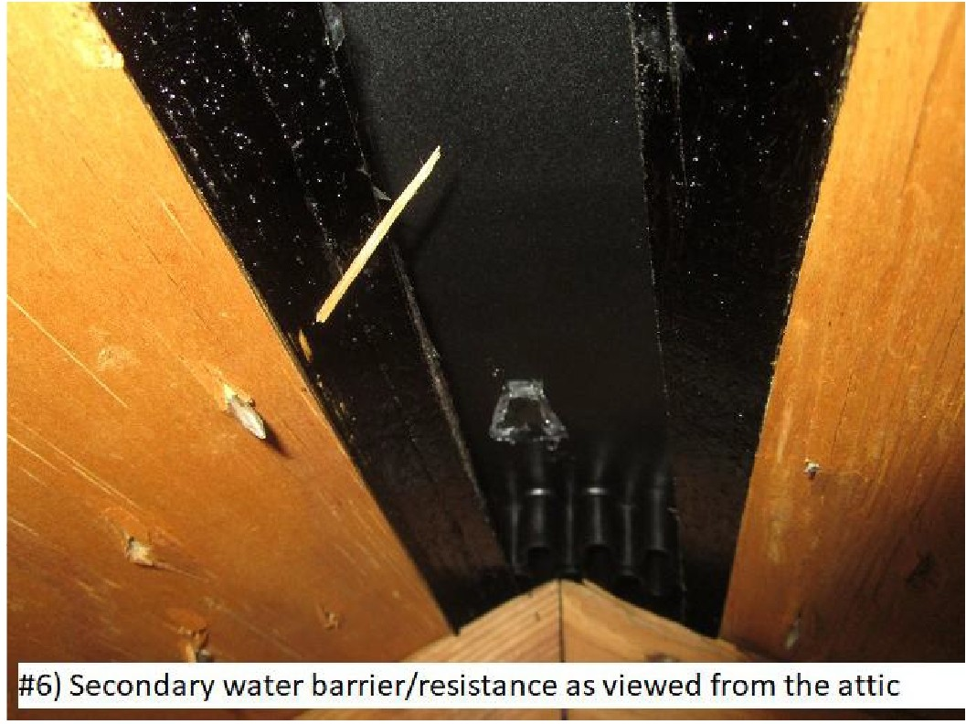
#6) secondary water barrier
- - -- - -

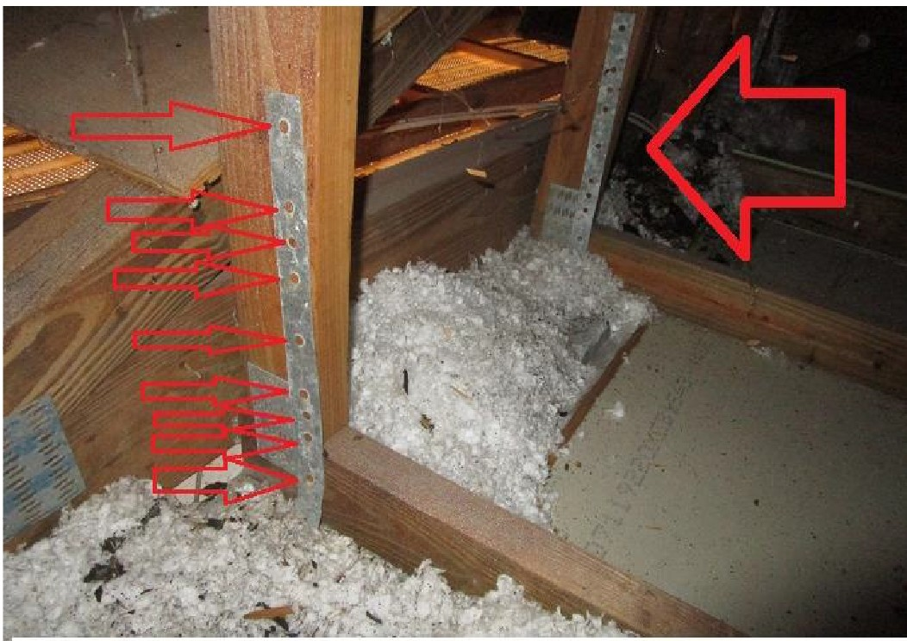
#4) r ofto wa ll att achm ent : hur rica ne cli ps

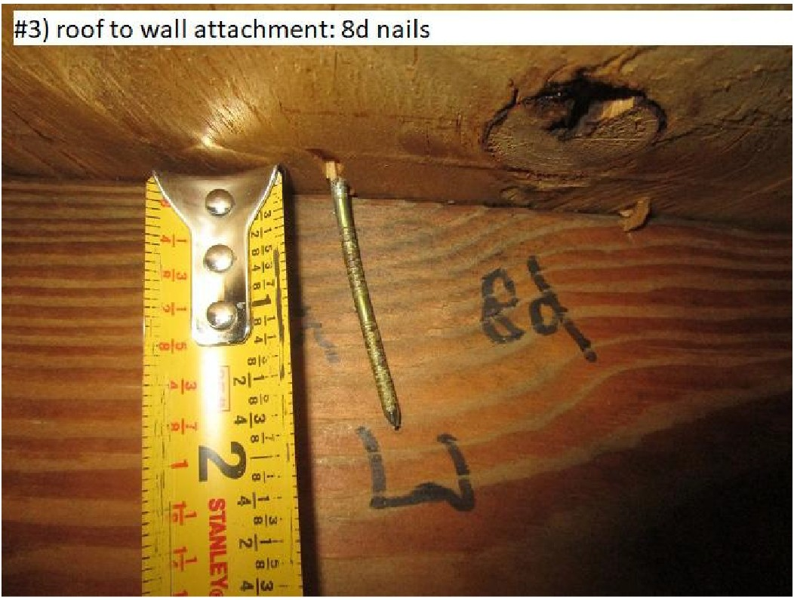
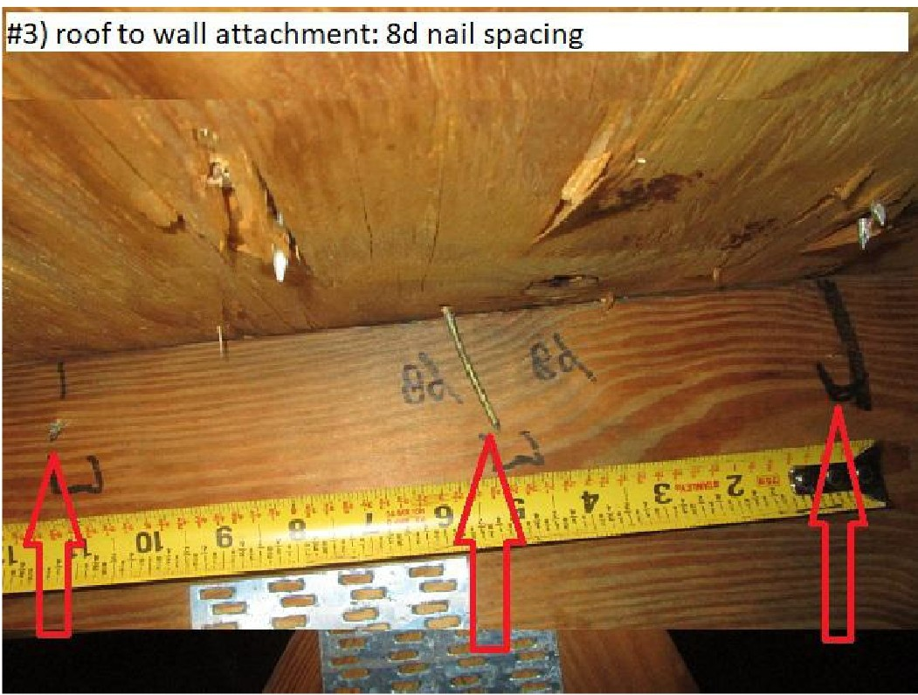

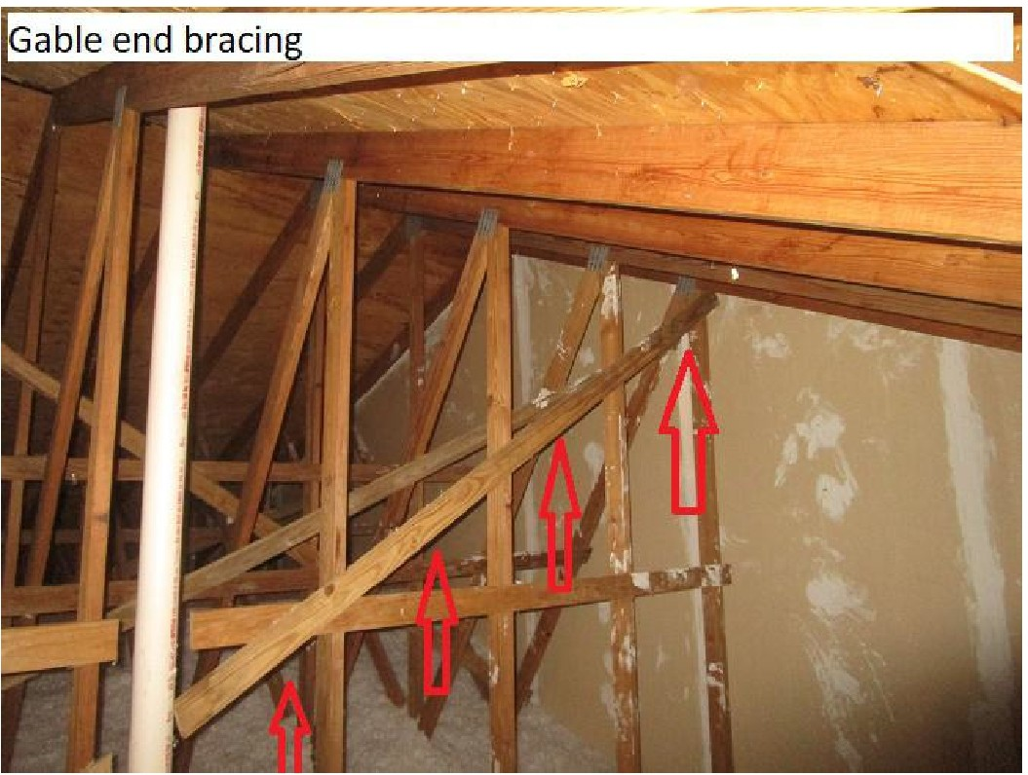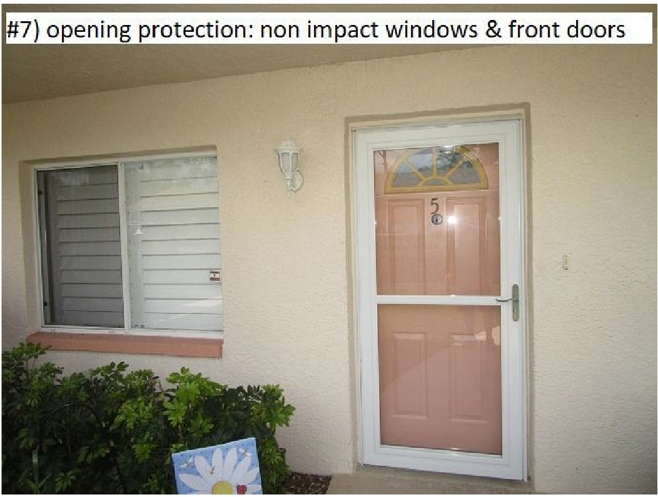

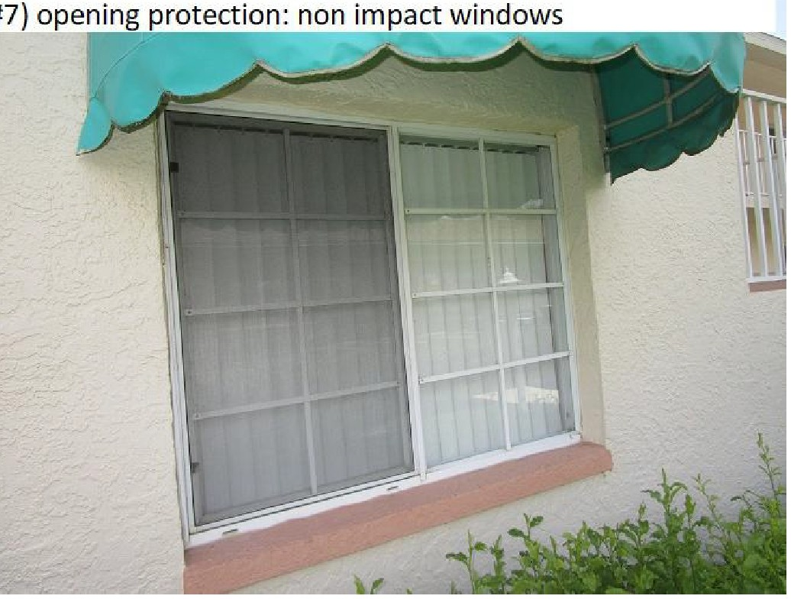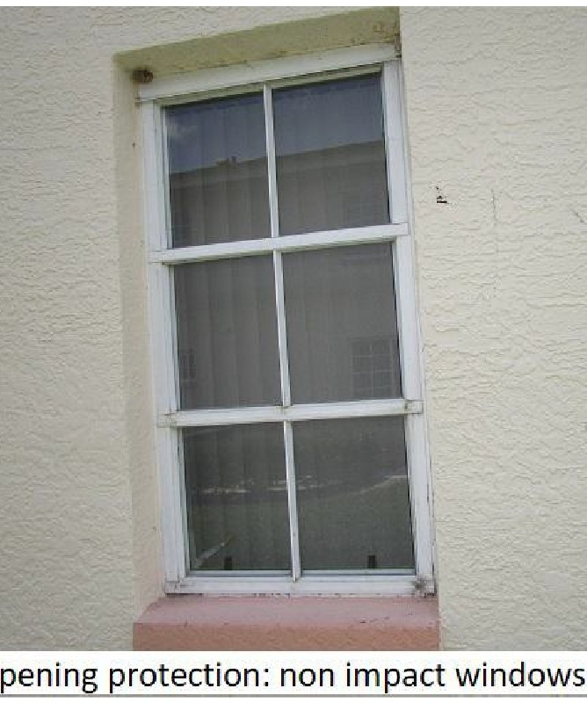#7 o

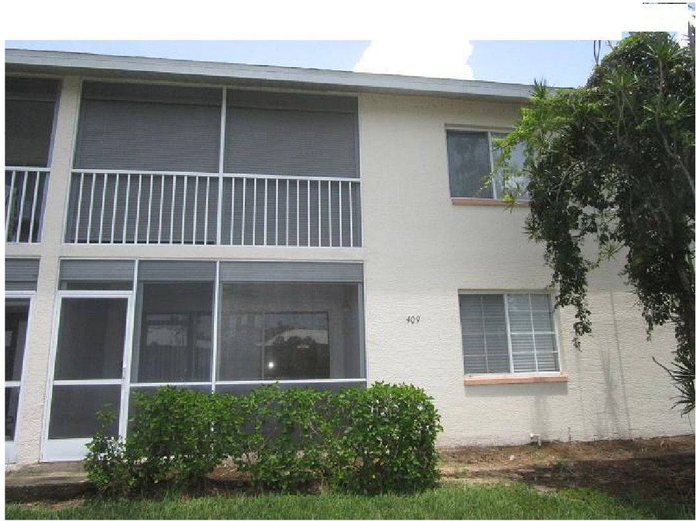7) opening protection: rear porch non impact slide rs
#7) open ing protect io n :some porches & windows have shutters
< r
