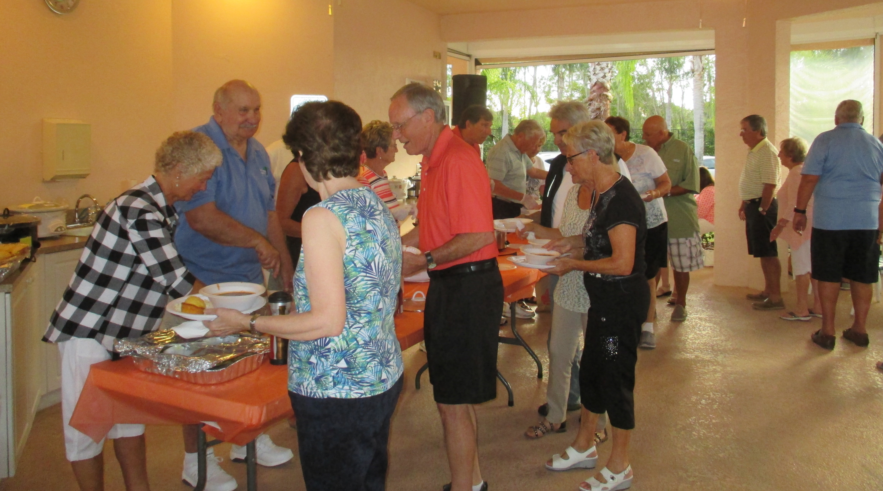

Country Western Chili Fiesta

Date: Tuesday, February 5th
(Rain Date February 6th)
Place: Pool #3 Pavilion and Deck
5:30 p.m.
Cost: $10.00 per person
(Bring your beverage of choice)
Call: Toni - 724-681-2789
Menu: Mild or spicy chili or white chicken chili,
Cornbread & Coleslaw.
“Dessert donations would be appreciated.”
Western attire is suggested but not mandatory!
Limited to the first 125 people.
(Donations to St. Matthew’s House would be appreciated)

