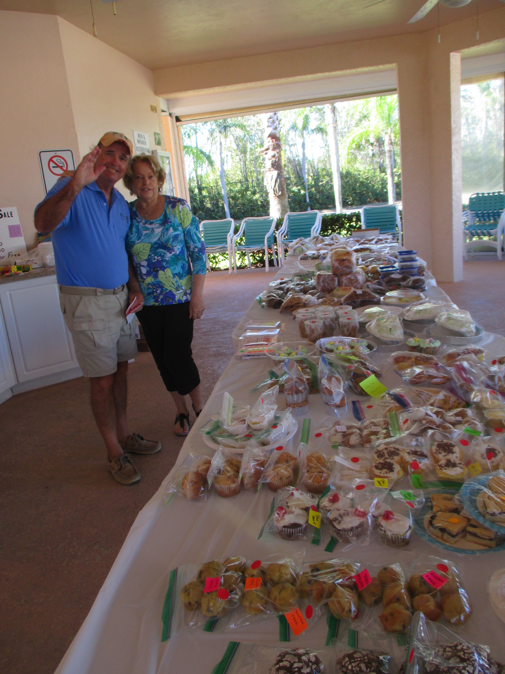

Bake Sale – Logo Sale
Saturday, March 2nd

Pool 3 Pavilion 11:00 a.m

We will have a variety of samples for both men and women: sleeveless, short and long sleeve shirts, T-shirts, sweatshirts, T-shirt dresses, hats and sport towels.

